Heros of Pymoli Report

Due : Saturday, January 23, 2021 by 12:59 pm | By Melinda Eudy

# Background

Fantasy game Heroes of Pymoli – free-to-play, but players are encouraged to purchase optional items that enhance their playing experience.

# Data Used

Break down data to show the following: Total # of Players, Purchasing Analysis, Gender Demographics, Purchasing Analysis by Gender, Age Demographics, Top Spenders, Most Popular Items and Most Profitable Items. Determine three observable trends from the data.

# Observable Trends, based on the data provided

1. Most Profitable Item and Most Popular Item – Top e of the top 5 are the same.

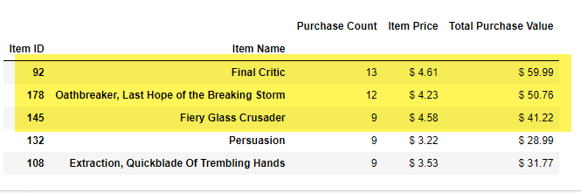

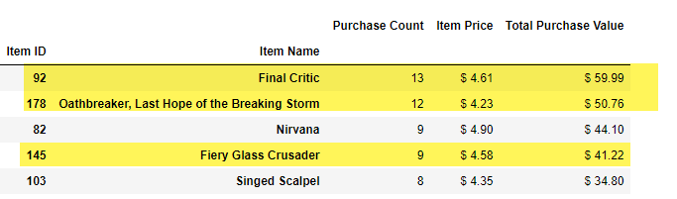

1. The Age group that purchases the most items is 20 – 24. Followed by 15 – 19, however there is a significant drop in purchases between the two.

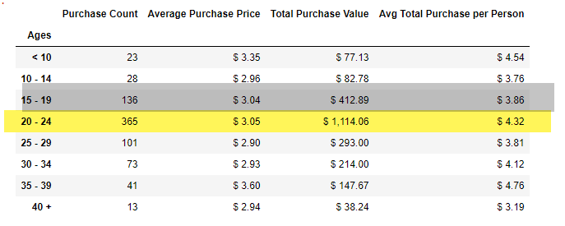

1. The percentage of players are Male. They are far more likely to play the game.

